Base Kirby Creation

The base Kirby is a very important step in the process of creating all the Kirby variants. With it we can derive all the variants. In this first section we will be presenting the creation of the base Kirby, that will be later used for the variants. First, we start with a simple sphere 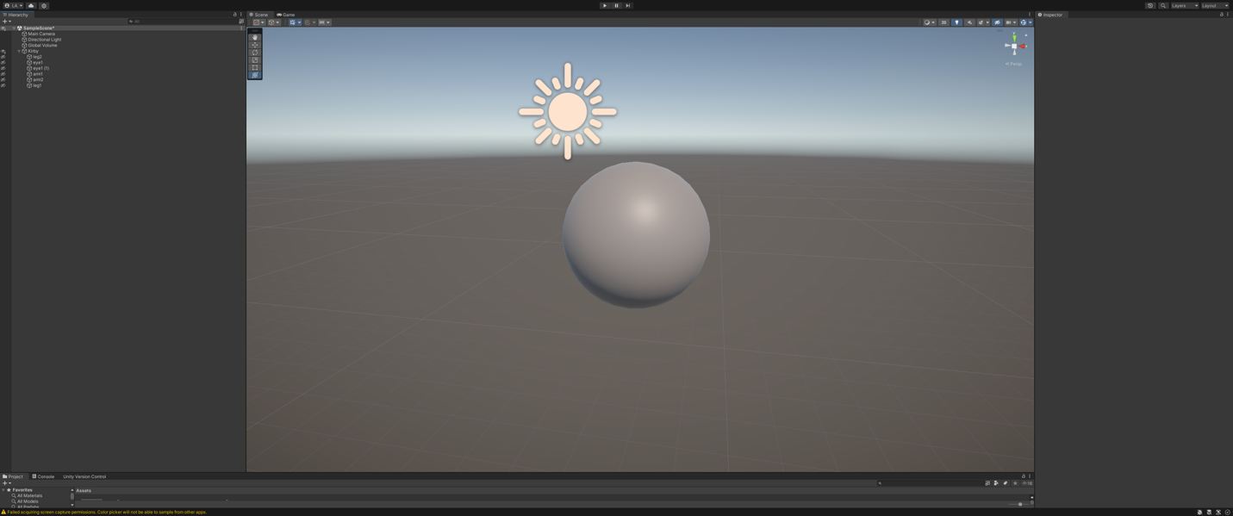

Now we add the eyes 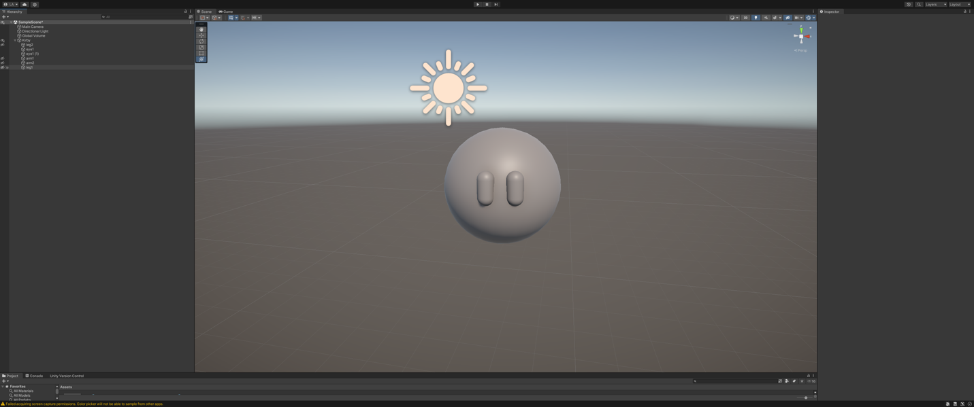

Add arms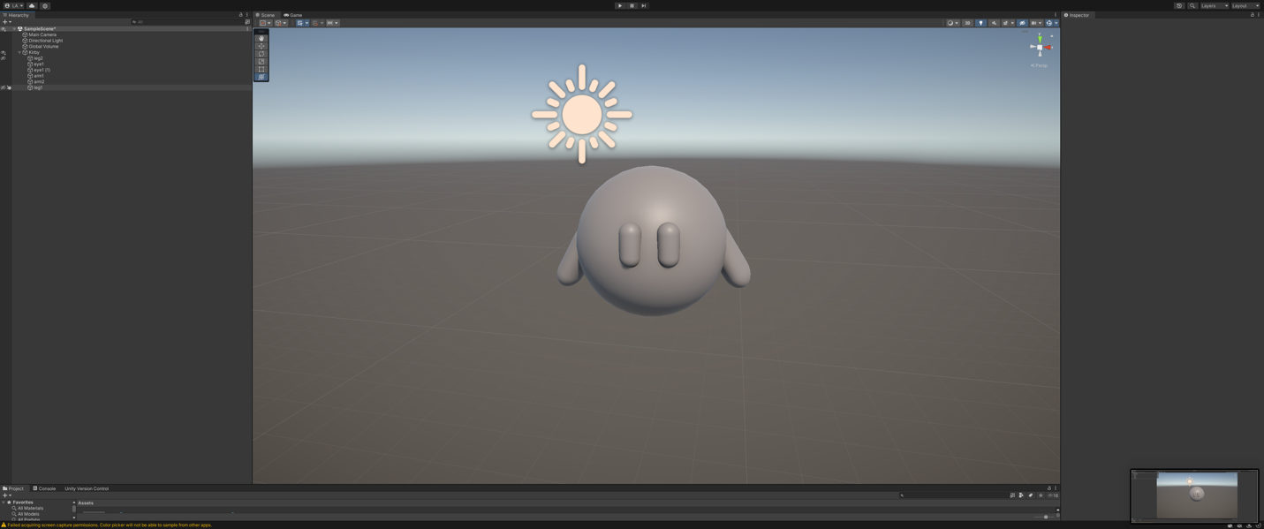Add feet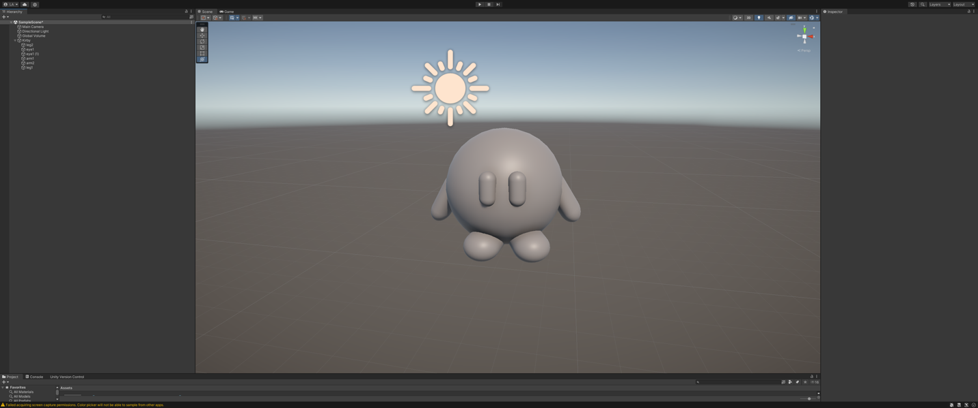

Create object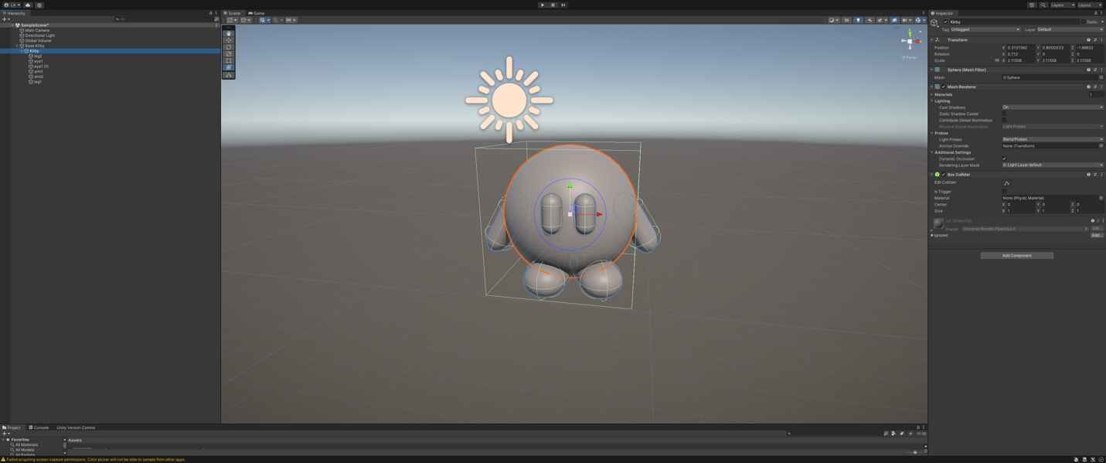

Create prefab

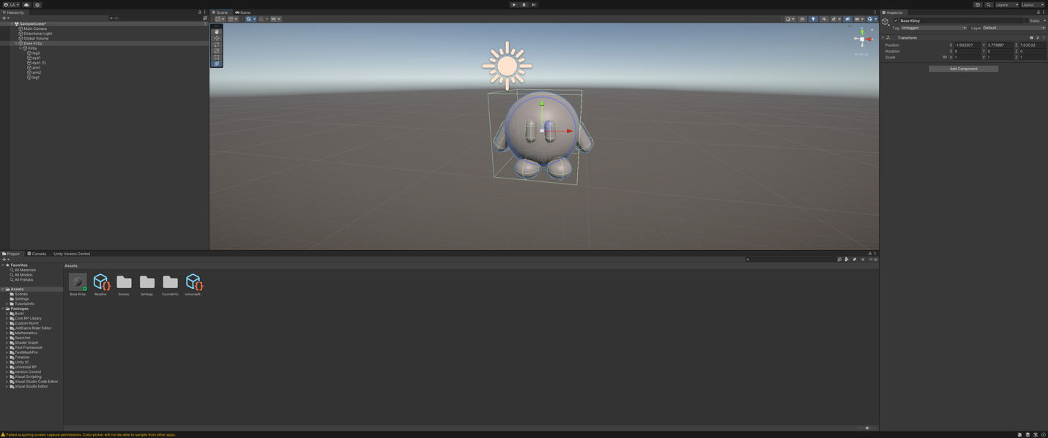

Add color

Now we have the base Kirby prefab, we would like to add some color to it. This would make more appealing and adds life into the Kirby and its variants. To do this we would first create a new folder in our assets folder, called “Color”.

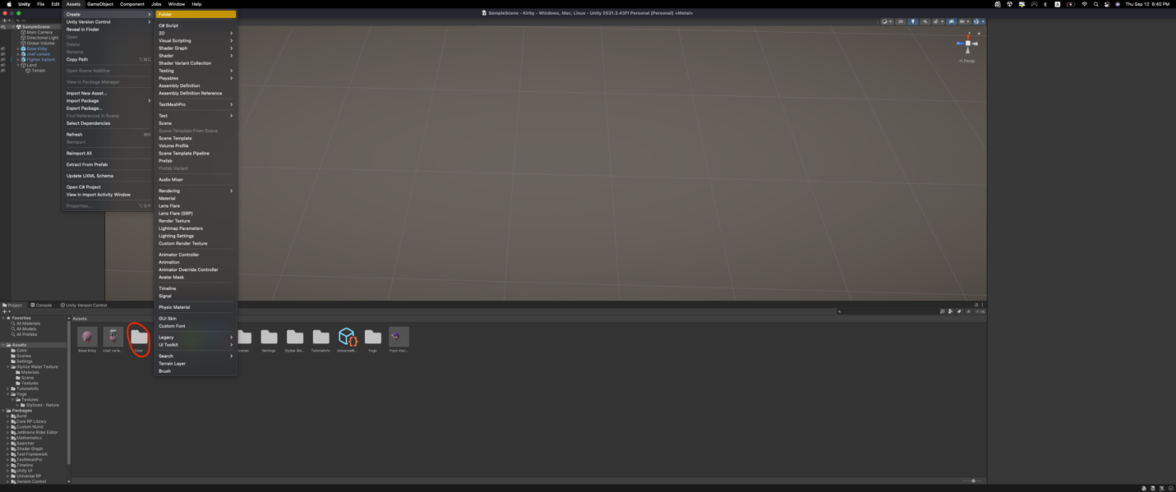

Next, we create a new material in the color folder and change the color to resemble the colors of Kirby. In the example image we created an example color.

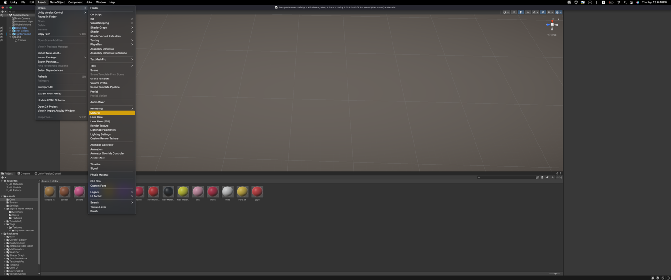

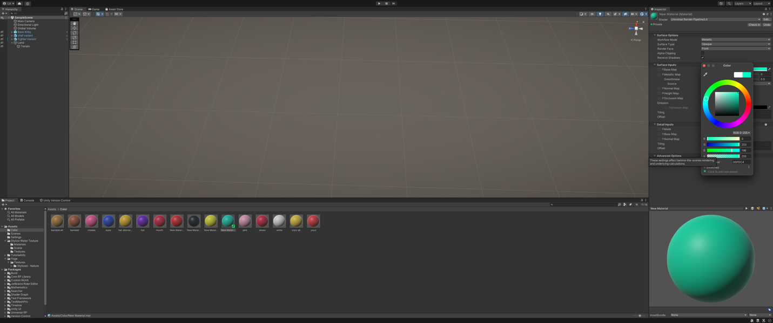

When we have the color folder with all the colors we need, we can click and drag the color to the section we want to color. The first image represents all the colors in the color folder, the rest of the images take us through how to add color. We first select the color and we drag and drop it to the area we want to color.

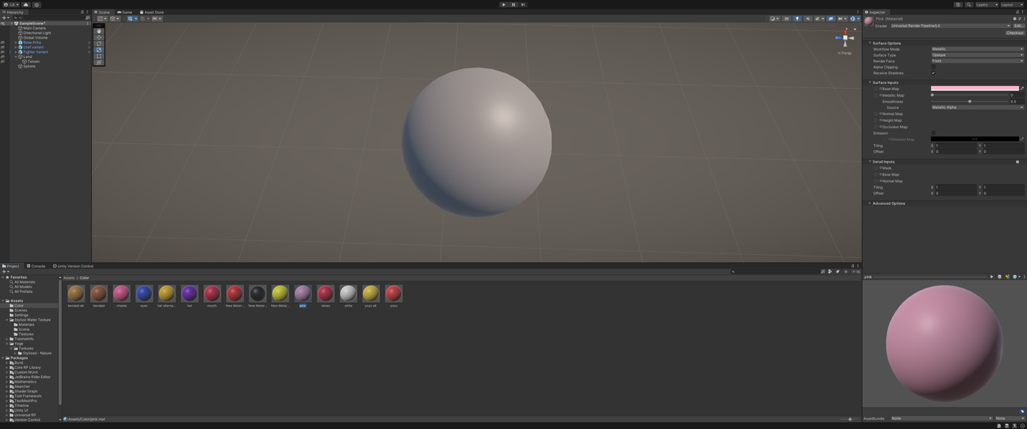

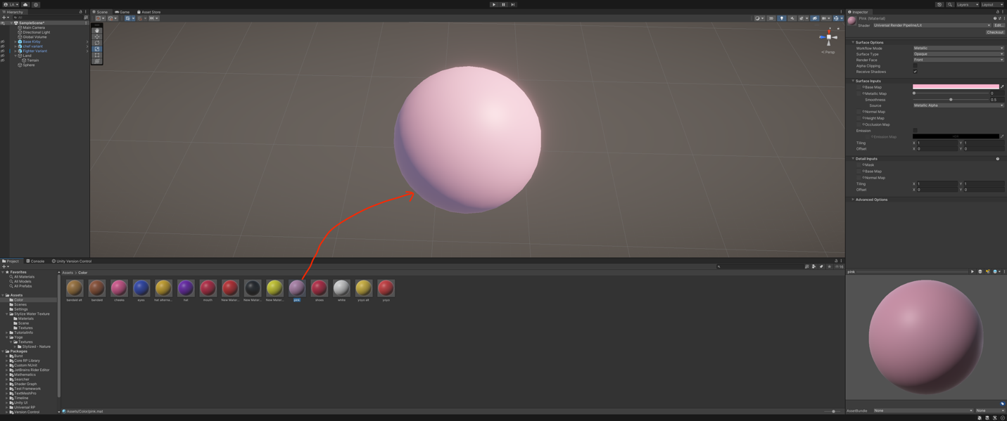

Variant Creation

Now that we have a colored prefab of the Kirby, we would proceed to create a Prefab Variant and edit it to resemble the Kirby variant we want. We can select this prefab and create a prefab variant, by right clicking on the prefab, selecting create and then click Prefab Varian.

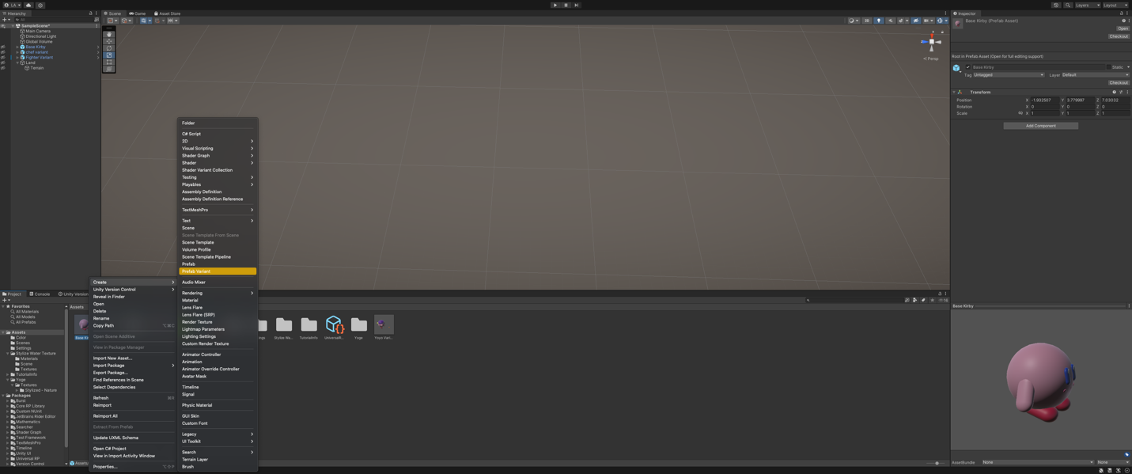

When we create the prefab variant, we can edit it and create the Kirby variants, this is an example of one of the variants created using the Base Kirby Prefab. All other variants are created in the same way.

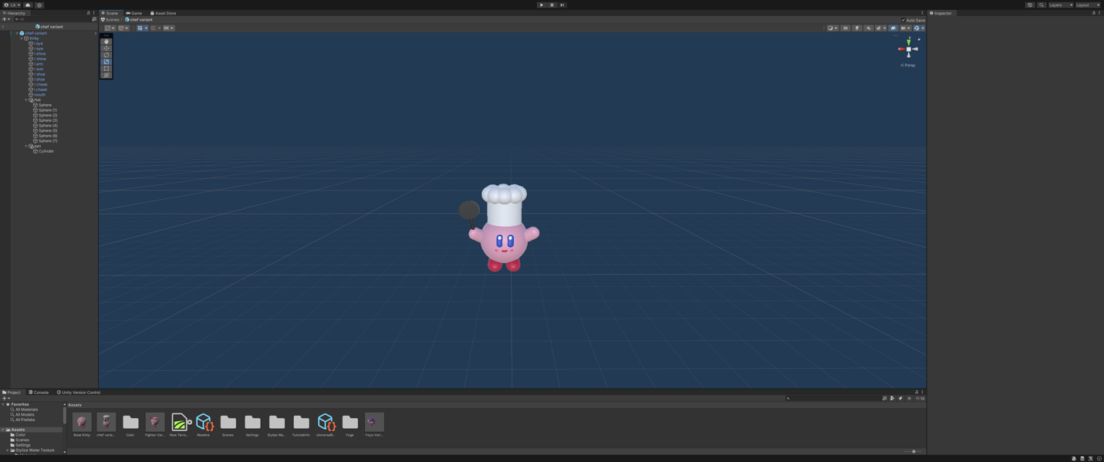

Terrain creation

To start with the creatin of the terrain we first need to create an empty object, that we called “Land”.

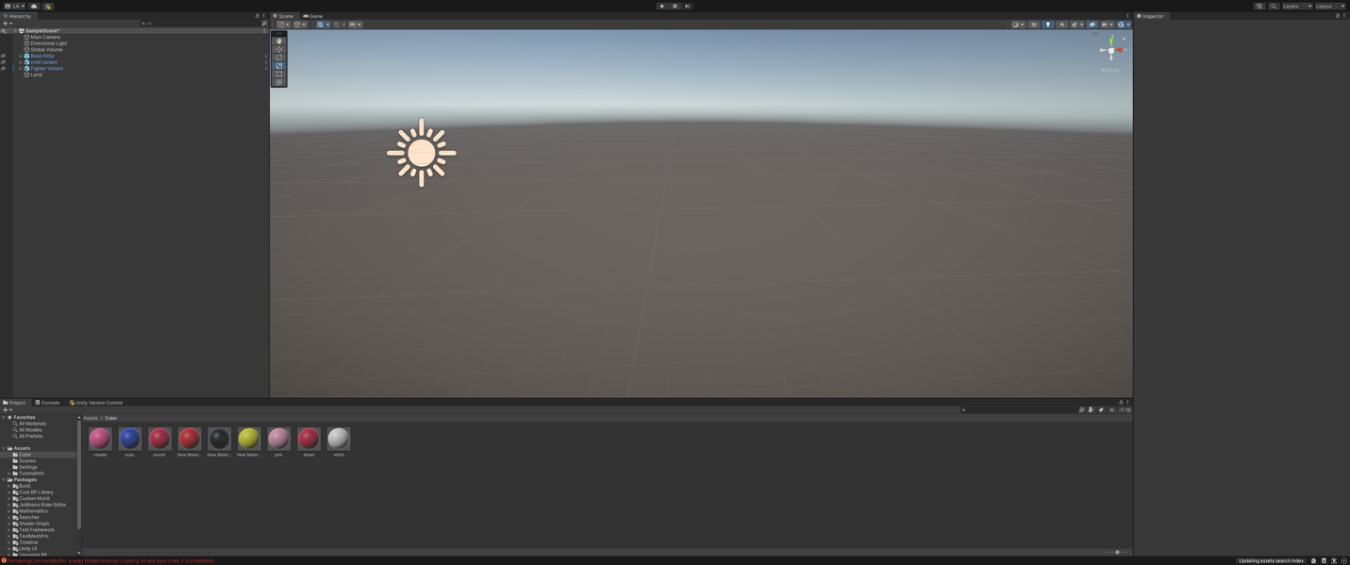

In this empty object we create are terrain by right clicking on the side panel and select 3D object and then terrain.

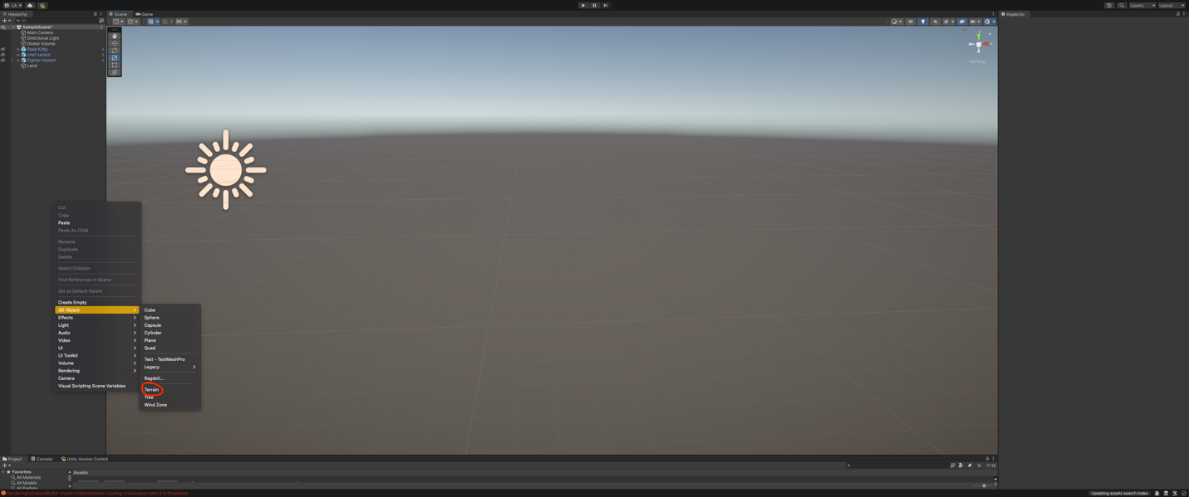

Now that we have created our terrain, we set the dimensions of the terrain.

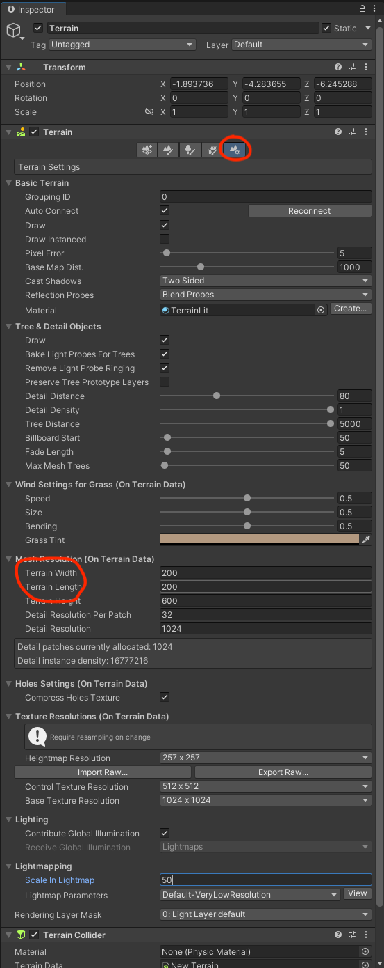

We then set the height in the “Set Height” section.

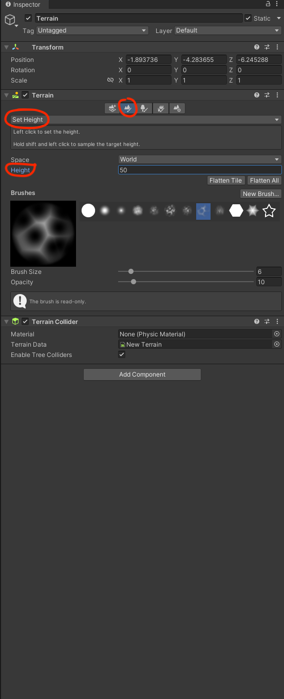

Then we can go the “Raise or Lower Terrain” section. With this if we hold left click, we raise the terrain, creating hills and mountains, and if we hold shift and then left click we can lower the terrain, creating rivers and lakes.

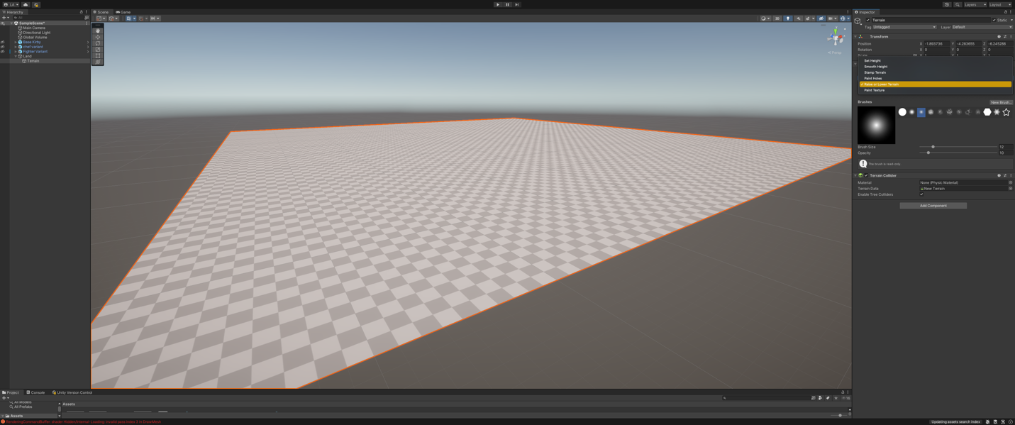

The next step is to choose a part of the map of Puerto Rico to recreate for our map.

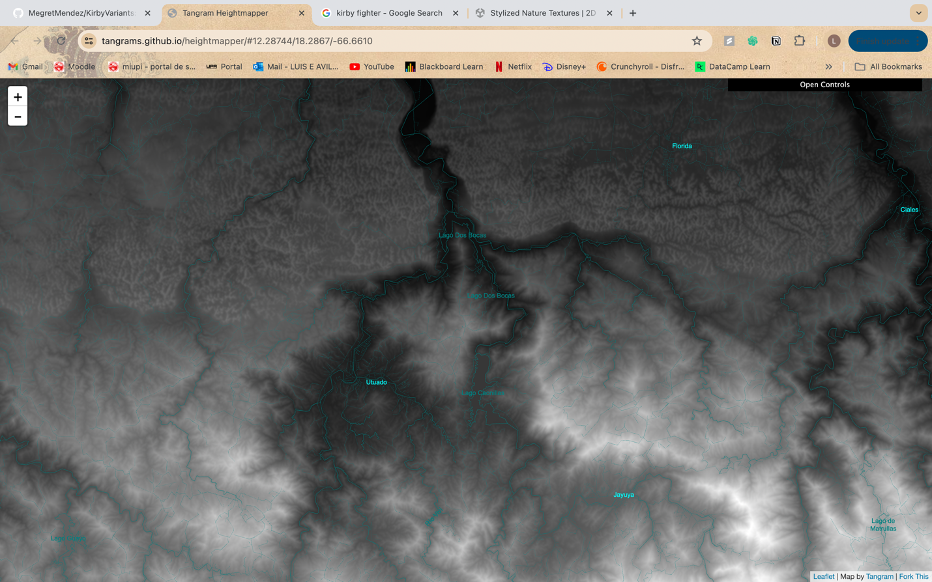

When we have the section of the map, we want we proceed to recreate it using the “Raise or Lower Terrain” tool. Remember that left click raises the terrain and shift + left click lowers the terrain.

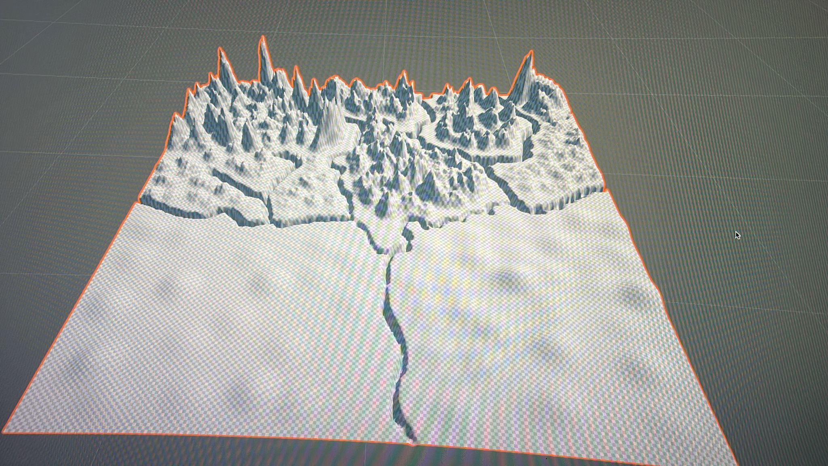

Now we have created our terrain, we can now proceed to add some textures to our map. This helps give it more color and adds life to the map. We do this by first going to the asset store, this is shown in the image bellow. 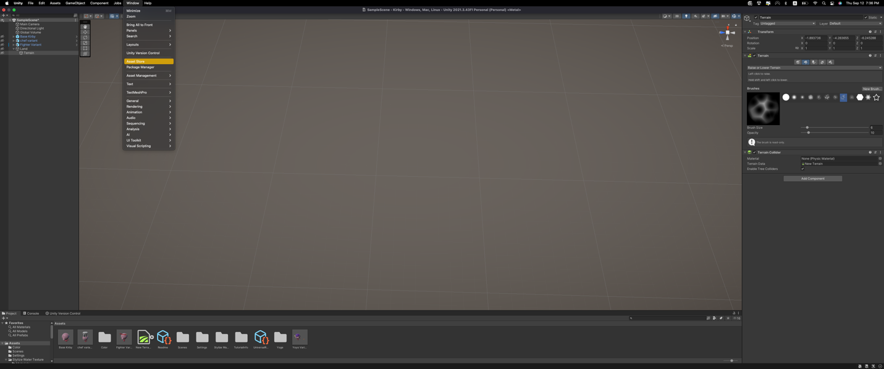

When we go into the asset store we can then proceed to search for a texture pack we want. When we have it we click “Add to My Assets” and it will be added to the Unity account. We selected two assets, the first one add water texture for the rivers and the second one add different styles of terrains.

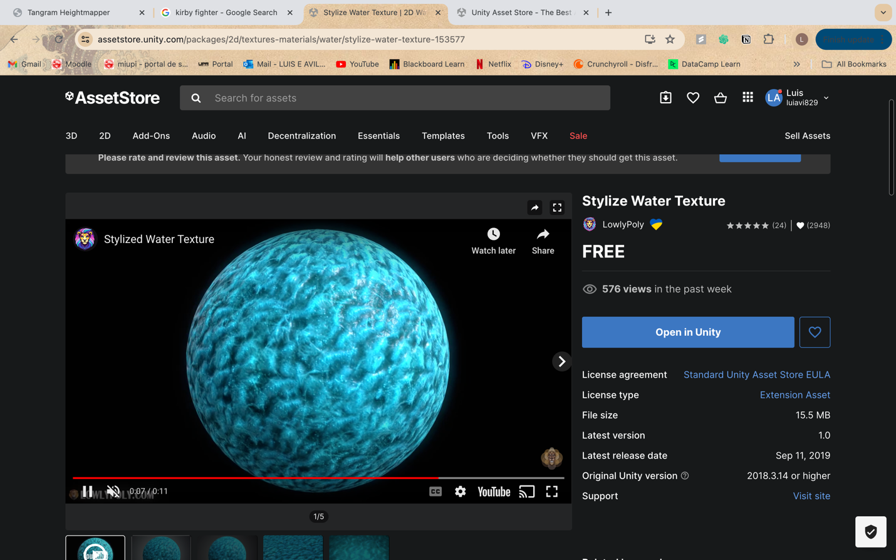

NOTE: In this case we don’t see the “Add to my Assets” button this is because it is already added.

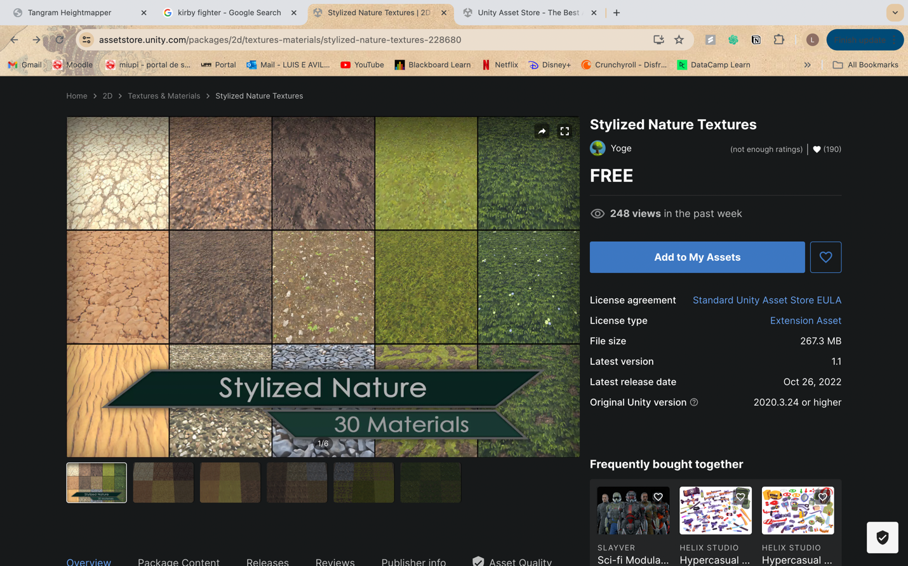

When we have them in the Unity, we download them and import them. Now that we have the texture, we proceed with adding the texture to the map. To do this we go to the “Pain Terrain” section. Here we select the “Edit Terrain Layers…” button.

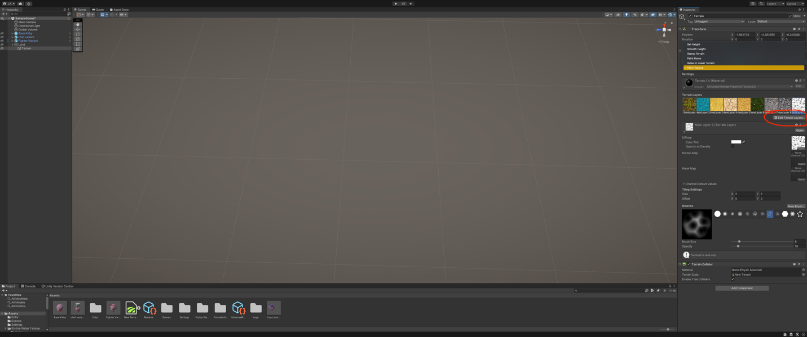

Then we click the “Create Layer” button, and menu appear and here we select the terrain we want by double clicking it. It would then be added to “Terrain Layers”. To use the we can select the one we want and use the Brushed to paint with them.

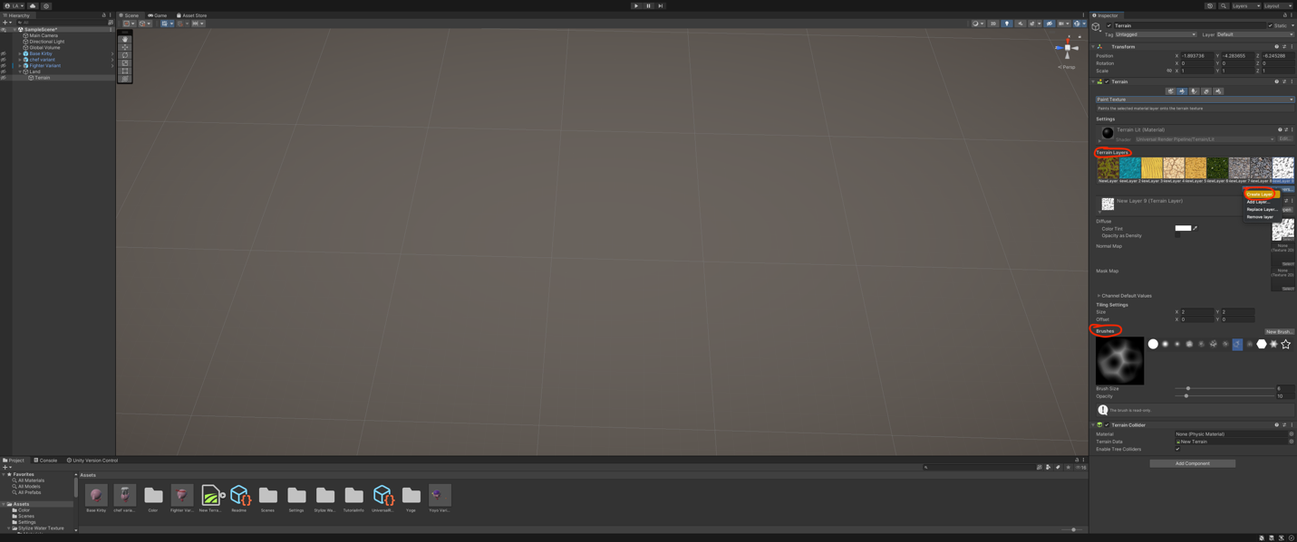

FINAL PICTURE

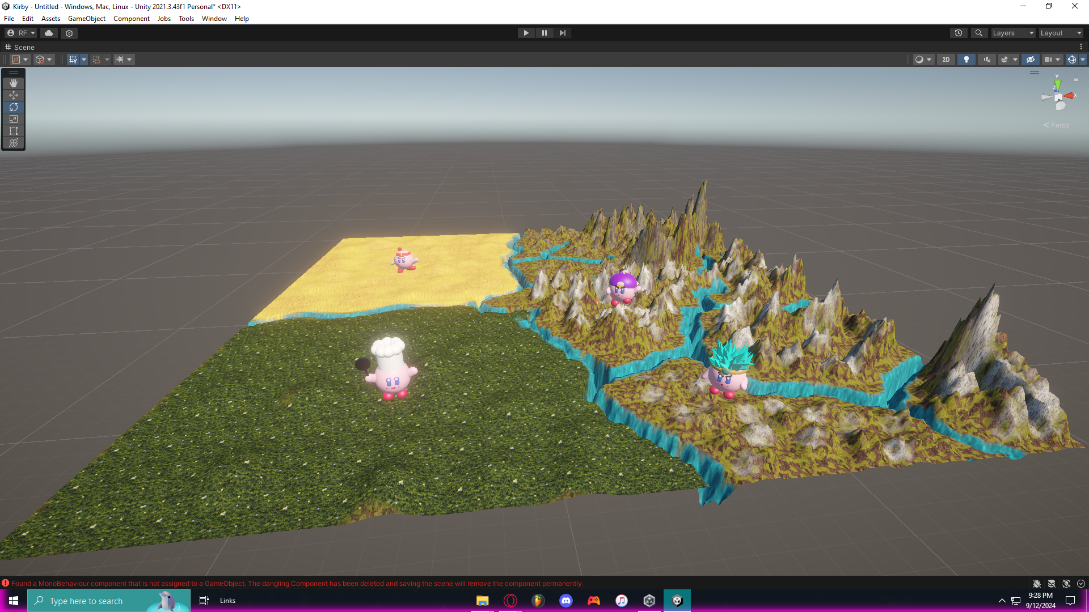

Personal Stories about Kirby

Ricardo A. Fernández

Kirby and I go waaay back. Growing up, my big brother and I were always glued to our Nintendo consoles, and Kirby was there for the ride from the very beginning. My first taste of the pink puffball’s adventures was thanks to my big brother, who introduced me to Kirby’s Dreamland on the Gameboy. I didn’t fully appreciate it back then—I was young, and to me, Kirby was just another game in our rotation. But little did I know, Kirby was going to stick with me throughout my gaming journey.

Fast forward to the DS era, and that’s when things changed. I remember the day I bought Kirby SuperStar Ultra—this was my Kirby game. It wasn’t my brother’s, it wasn’t something handed down, it was the first game I bought for myself, and honestly? To this day, I think it’s one of the best 2D platformers ever made. I’ll say it: better than Mario, hands down. The tight controls, the diverse copy abilities, the epic boss fights—SuperStar Ultra had everything. And that moment when I first unlocked "The Arena" mode? Yeah, that was peak gaming for me.

Then came the Wii. By then, I had fully embraced Kirby as my main in Super Smash Bros Brawl, floating around the map and swallowing opponents like it was my day job. But that wasn’t the only time Kirby caught my attention on the Wii—there was this game called Kirby’s Epic Yarn. You might’ve missed it if you weren’t paying attention, but man, what a game. It was different, sure, no signature copy abilities, but the art style, the music, the cozy vibes—it was so unique. I loved every moment of it, and honestly, it deserved way more recognition than it got.

Even today, when I need that nostalgic hit, I fire up an emulator on my phone and dive right back into Kirby SuperStar Ultra. It feels like catching up with an old friend, one that’s always been there, from my Gameboy days to now. Kirby’s been with me every step of the way, and I can’t wait to see where our adventure goes next.

Luis Avilés

When I was younger, Kirby was always my go-to character in Super Smash Bros. Brawl on the Wii. I loved how he could float effortlessly above the battlefield and then dive down with his drill kick, catching opponents off guard. But what really made Kirby special was his ability to inhale opponents like Mario and Link, copying Mario’s fireball or Link’s bow and arrows. No matter who I faced, Kirby could adapt, turning into a tiny pink force of nature. It felt satisfying, mastering a character who looked harmless but could dish out serious damage with a unique move set.

Andres Rosner

I remember playing “Kirby: Air Ride” back when I was a kid in the mid-2000s on my GameCube with my brother and friends. The first time I was introduced to the game was during a sleepover at my friend’s house after a long week of school. Following a game of tag, we came back to his house tired and down to relax with some more games. That’s when he pulled out this gem called “Kirby: Air Ride” from his pile of games. We began playing the game and got hooked instantly. On the surface, the game is a typical kart racer with split-screen and fun tracks, featuring wonky controls and cool Kirby characters. However, the real fun was in a game mode called City Trial. In this mode, you free roam around a city with various environments, like a parking lot and a volcano, looking for better rides and upgrades while everyone else tries to steal your upgrades, all the while various catastrophic events unfold in the background. After the city exploration ends, you take your upgraded ride to a trial to test its specs, such as speed or airtime. Whoever has the best combination of ride and upgrades for the trial wins. Having had a blast at my friend’s, I asked my mom if she could get me the game and for my next birthday, she did!